# **Introduction to CSS**

# **Class: BSCS 6A/6B and BSSE 5B**

# **Instructor: Syda Fatima**

# Consider a web application to develop

* CONNECTIONS: a smaller version of social web
* Users can register themselves
* After registration they can send a text message to anybody who is registered with the website
* User’s can view the received messages

# The process

* Determine the requirements of the site
* Group the required information
* Make a site map
* Identify key elements for each page
* Decide about the arrangement of information on each page
* Translate the design into code

# Determining requirements

* Understanding the audience
* Who? Who will visit the site?
  + You can create fictional visitors
  + Men and women of 20 to 50 years of age
* Why? Why have they come to your site?
  + Send messages
  + View received messages
* What? What does a visitor need to achieve a goal?
  + Will they be familiar with your product?
* How often? How often can you realistically expect them to visit?
  + In-order to make changes
* Things You Want the Site to Do
* Determining the requirement of the owner of the site which are not already listed
  + User must register themselves in-order to send and receive messages

# Grouping and categorizing

* Group related information/sections
  + Home page: login form, registration form
  + User page: user’s information, recent messages
  + Inbox: Received messages
  + Outbox: Sent messages
  + Send a message: Send message form

# Make a site map

* Site map shows how many pages you need and how they relate
* Usually look like either a family tree or folder list

**Home page**

**User page**

**Inbox**

**Outbox**

**Send a message**

# Key elements for each page

* Common sections (header, navigation, footer etc.)
* Page specific sections
* Common Sections (header, footer)
* Page specific sections
* Home page: login form, registration form
* User page: user’s information, recent messages
* Inbox page: received messages
* Outbox page: messages sent by the user
* Send message page: form to send a message

# Arranging elements on page

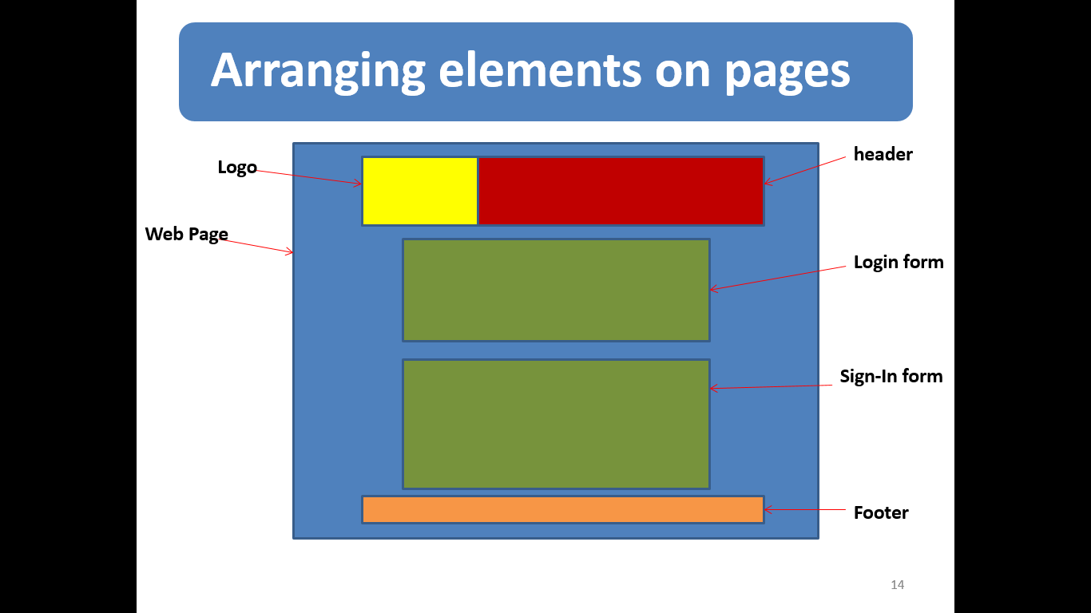

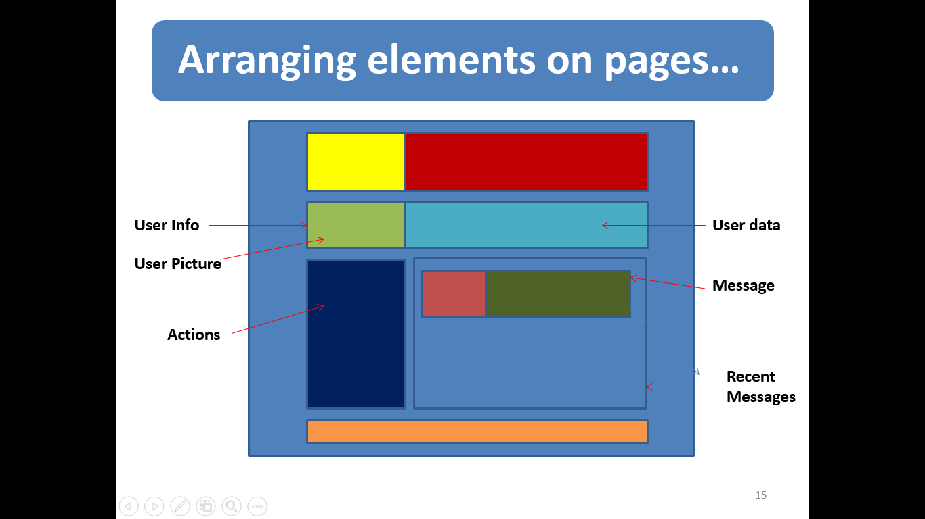

# Translating design into code

* Liquid vs Fixed design
* The Div tag
* Coding the design

# Liquid vs Fixed

* Liquid Design
  + designs automatically fits to the screen
  + Use percentage values to declare height and width of sections
* Fixed design
  + Designs remain fixed width
  + Use fixed values to declare height and width of sections

# The <div> tag

* Defines a division or section in an HTML document
* Visually, allows us to make containers that can be formatted
* Can be declared as
  + <div>……</div>

